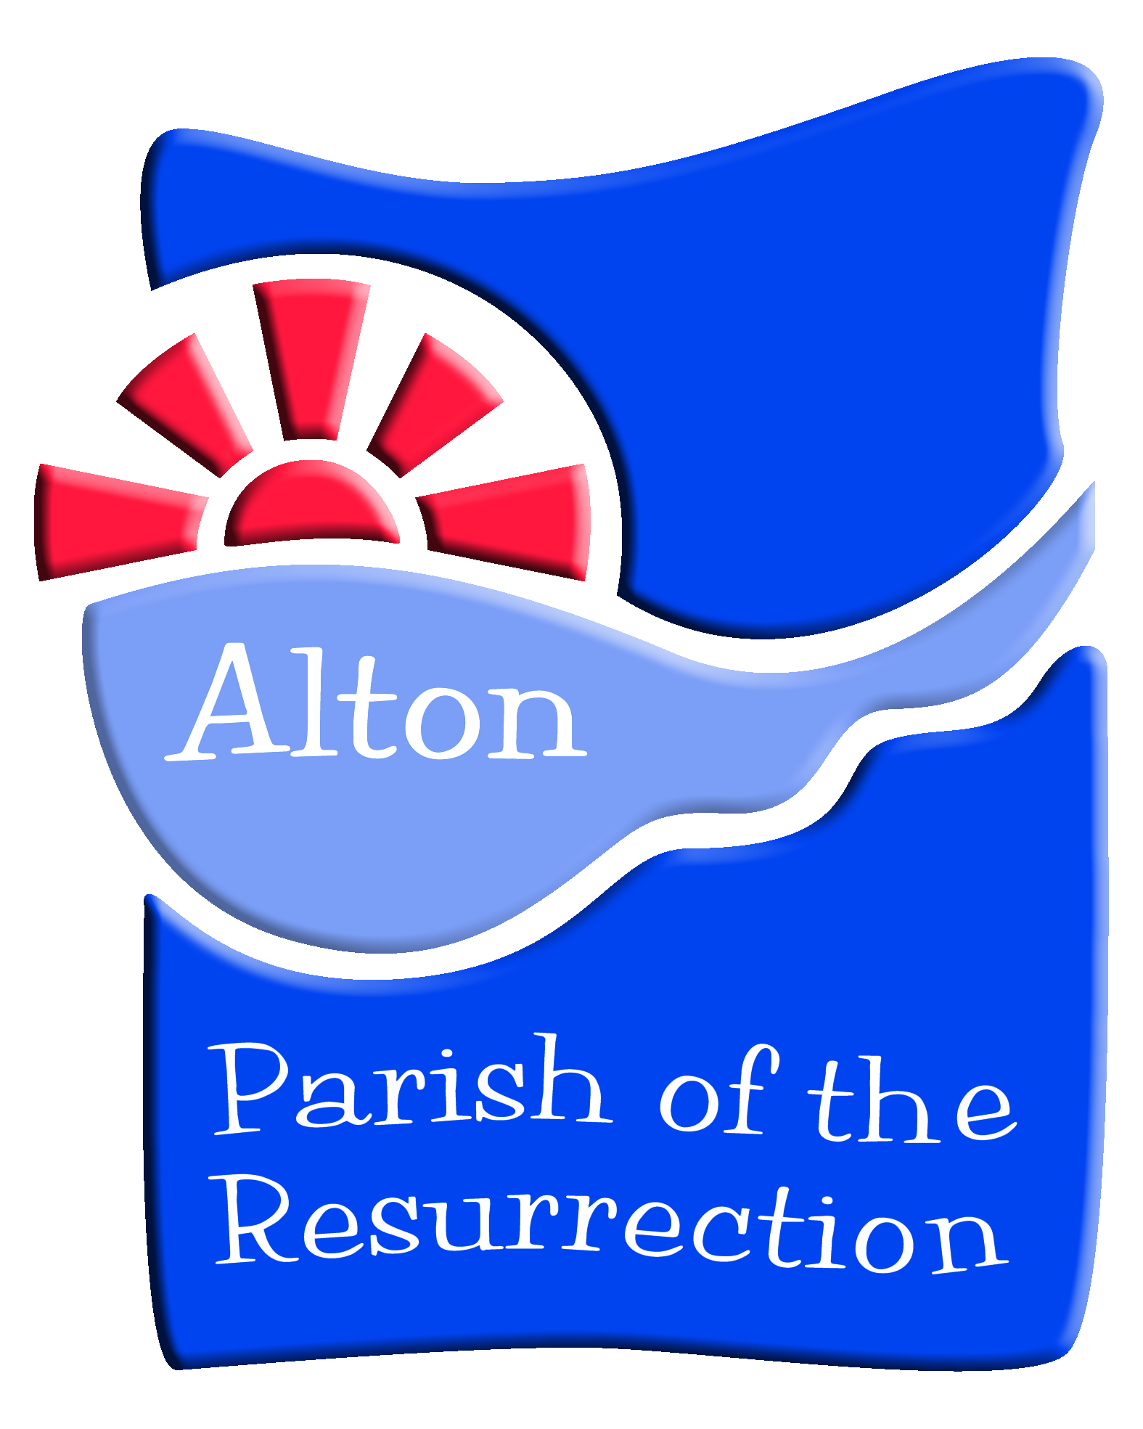
AGENDA
THE PARISH OF THE RESURRECTION ALTON

Sunday 28th April 2019
St Lawrence Church

ANNUAL MEETING OF THE PARISHIONERS
  - Bible Reading & Prayers
  - Election of Churchwardens

ANNUAL PAROCHIAL CHURCH MEETING
  - Vicar’s Report
  - Report on The Five Year Plan
  - Report on new Electoral Roll
  - Elections to PCC
  - Financial Statements of Parish for period up to 31st Dec 2018
  - Reports on Fabric
  - Report of the Deanery Synod
  - Safeguarding
  - Appointment of Sidespersons
  - Appointment of Independent Financial Examiner

Dates of PCC Meetings 2019/2020
all at 7.30pm
Thursday 20th June 2019
Tuesday 24th September 2019
Wednesday 20th November 2019
Wednesday 5th February 2020
Tuesday 24th March 2020
APCM - Sunday 26th April 2020
Vicar’s Report - Annual Parochial Church Meeting - 2019

As I reflect on the past year and the life of our parish I do so with great gratitude for all that God continues to do amongst us. This is a fantastically missional parish with a desire to serve God with all that is presented to us. God calls and we typically find ways to respond with generosity and sacrifice. So I start this report with a profound gratitude to all of you for the ways, big and small, that you make this parish such a wonderful place to live and be. Thank you for seeing opportunities and grasping them, for continuing those long established ministries and activities, for being enthusiastic as we grapple with holding everything together. I am convinced that this is only true because we take our worship and prayer seriously and allow them to be the focus for energy.

This past year has seen a number of things which we need to celebrate:

  - we are now in the second year of trading with Resurrection Furniture and I am indebted to The Trustees and the many volunteers for their diligence, discemment and ongoing commitment to this project.

  - the re-ordering of The Church of the Holy Rood in Holybourne has been completed and what a transformation! We are enjoying the flexibility of the space, the ease in which refreshments can be served and the fact that we can now go to the loo inside the building. A big thank you to all who served on The Living Space Project Team in these last few years. There is now ‘phase two’ being planned and researched - to replace the ageing lights with a new improved fittings an fixtures, to install an Audio Visual System and host an ongoing Holybourne Village Archive display.

  - the launch of the Church@4 services in Holybourne and at St Lawrence. These inclusive Sunday afternoon services have brought new life to all-age worship and our engagement with children and their families. It is also encouraging that The Butts Church have started their own to complement ours so that across town there is Church@4 on three Sunday afternoons. Thank you to those who have stayed with this initiative and formed planning teams to make them happen so effectively. Many of the Church@4 families are also involved and attend The Lighthouse at St Lawrence Church on Sundays. Our provision for children, especially at St Lawrence is so good and it is a joy to see them joining us for worship so often.

  - our Anna Chaplaincy continues to serve and minister to the older people of our community with great dedication and a pioneering spirit. Thank you to Rachel and Debbie for all you do. It is amazing to think that what was started here in Alton ten years ago has now got a wide national following with Anna Chaplains and Friends being appointed and commissioned all over the country.

  - the ecumenical scene in Alton is thriving. I am so pleased to part of a wider team of minister and church leaders which such a heart for unity. A particular highlight has been the Lent Talks which now have happened twice together. Many people have commented to me on how well they are delivered and how they are valued. My hope is that we can do more and more together - Jesus himself prayed that we should be ‘one’.

  - the ministry which is offered to our local schools is vast. There are a number of members of the parish who serve as governors being part of that strategic leadership. It is a time consuming role, thank you. Collective Worship is provided to so many of our schools by the clergy team and from those in other local churches - it is a wonderful opportunity to share our faith with the children but also to allow their faith to encourage us. I am always touched by their singing and praying, we could learn so much from them. We have three Open The Book teams made up of people from local churches who faithfully go and tell Bible stories in all our primary schools in town. This is always so well received, thank you to those who take time to make this a priority. Keren Brake has the title of Schools Ministry Co-ordinator and has taken the time to make opportunities a reality such as the recent Easter Experiences for all Year 3 pupils across the town.

  - Ali Wright is in her second year as Youth Minister and a number of young people are benefitting from her work. I particularly want to thank her for her activities at Amery Hill and Eggars, our two secondary schools. It is important that we reach out into the lives of the teenagers of our town.

  - the Covenant Youth Choir goes from strength to strength and has recently returned from a France Tour. We have enjoyed their music at concerts and services this year, thank you. They have recently been supplemented by The Covenant Training Choir for younger children and their music is taking off and developing at a pace. Joy Windsor adds to all the other of her responsibilities to make CYC and CTC a success, thank you to her and to the other volunteers who so keenly help her.

  - the appointment of two new Parish Administrators has been vital. Carole and Philippa have been a great asset and have been introducing new systems to the office. They are getting there with the myriad roles within the job and I couldn’t function without them.

  - This year has seen the development and launch of our Five Year Plan which is to drive us forward in mission and ministry. There was a good consultative process and time has been taken to explain it more fully in preaching and articles. It is imperative that we have vision - without it we perish! There is a PCC Committee which is set up to oversee its development and the committee will report separately at the APCM. As part of the Plan we have introduced ID Groups for our ongoing discipleship. We have had one term in which a number of people have engaged in various activities. We would especially like to see others offering to run small, time-limited activities which include Bible reading, prayer, faith encouragement and fellowship. What might you offer?

I am sure there is more I could add to my list. In fact, I often wonder how we manage to make so many activities, events and services happen. It with this in mind that I propose to focus a PCC meeting before the summer to evaluate and discuss how we might do fewer things and do them really well. Perhaps we fall into the category of over-stretching ourselves? Of course, this is a practical and pragmatic discussion but it has also to be prayerful and missional. I would value your prayers as the PCC undertakes this important piece of work.

Lastly I must pay tribute to all those who take responsibility and minister alongside and with me. I am very grateful to have such an enthusiastic and gifted Ministry Team - Joy, Lynn, Martin, Margaret, Rachel, Debbie and Ali. The Churchwardens and PCC have been a joy to work with and I thank them for their support and care of me as well as their ability to keep on top of the work of the four churches. It has also been year of goodbyes. We said farewell to David and Julie Hinks as David took up his new role as Managing Chaplain at Winchester Prison and then to Chris, Naomi and the children Bradish as Chris went first to London and now to Andover as Vicar of St Mary’s Church. We miss them all very much but know that we all follow God’s call. And so I am very much looking forward to God’s call to Gordon and Ruth Randall as Gordon comes as Associate Vicar. I can announce now that his licensing service will take place on Sunday 23rd June, 3pm in Holybourne Church with Bishop David presiding. Please put this in your diaries, let’s fill to overflowing the church.

All in all, a tremendous year in God’s service here in Alton, Holybourne and Beech. I thank God and I thank you. We have been studying of late in our Lent Talks the Lord’s Prayer. I have been especially drawn again to the phrase ‘Thy Kingdom Come, thy will be done’. It’s part of the prayer that directs us to think much beyond ourselves to see what God is doing and how He is calling. God’s kingdom and His will are the focus of all we do and I ask that you pray this often, with conviction and with confidence. I believe it makes all the difference.

With my love and my own prayers for us as a parish and for each one of us.
Andrew

PCC REPORT

The PCC has met five times this year

  - 19th June 2018
      - PCC Governance & Committees was discussed with new format and membership
      - Update on appointment of Parish Administrator & Communications Officer
      - Five Year Plan update
      - GDPR
      - Bell-ringing policies
  - 20th September 2018
      - Agreement of Terms of Reference for PCC Committees
      - Update on GDPR
          - a guide for PCCs
          - Consent form
          - Privacy Policy agreed
      - Paperwork for appointment of Associate Vicar
      - Report Finance & Admin committee on Stewardship
      - Other committee reports
  - 27th November 2018
          - Stewardship for 2019
              - booklet agreed
              - Parish Giving Scheme as preferred method
              - donate button on website
              - Tap and Go machine purchase
              - envelopes
              - card reader in office
              - thank you to Elizabeth Dain as Gift Aid Secretary.
              - Tim Sturt to begin as Donations Co-ordinator
          - The Kings Arms Project and Parish Youth Work
          - Committee Reports
              - Finance - looking at deficit for 2018
              - Budget for 2019 agreed with a £14K deficit
              - Agreed Conflict of Interest Policy, Investment Policy, Reserves Policy
              - Simon Goddard to be asked to be QI Surveyor for all four churches
              - Five Year Plan committee to report as part of Renewal of Giving period
  - 7th February 2019
          - Resurrection Furniture update around staff redundancy
          - Stewardship Update- good response so far
          - Diocesan Student Evangelism Project
              - Approval given to participate in this project with Ali Wright as link person. We will work with Alton College and in liaison and partnership with The Kings Arms Project
              - Will give us £6,600 in Years 1 & 2 and £3,300 in Year 3
          - Financial Update
              - Will be an overspend on 2019 budget of £5K
              - we will benefit from a recent legacy and increase in planned giving
          - Hiring Charges for Parish Buildings
          - Developement of use for IKnow Software
          - Committee Reports
          - Planning the APCM
- 26th March 2019
          - Resurrection Furniture update
          - Safeguarding Policies
              - Agreed a number of important policies on National Church Guidance and appointed Sally Kemp as Parish Safeguarding Officer
          - Approval of Annual Financial Accounts
          - Stewardship Update
          - Digital Giving

DEANERY SYNOD REPORT

Our parish Synod representatives are Peter Bell, Derek Gurney, Elspeth Mackeggie Gurney, Tori Hewitt, Lisa Hillan
Margaret Bell is a member of Diocesan Synod

Synod met 3 times in the past year.

June: Andrew Micklefield to be appointed as Assistant Area Dean. Following Janet Foster’s resignation as Lay Chair, Derek Gurney was elected. Andrew Micklefield gave a report on General and Diocesan Synod. Discussion was held on Strategy and Vision - prayer spaces, Growing Leaders Course, Mentoring.
Reminder of Diocean Synod elections in the autumn. Benefice of the Future, Simon Butler to be invited to give a talk on how it is going with North Hampshire Downs Benefice. Joy Windsor to be priested on 30th June. Where are we on Parish Mission Action Plans.
Simon Davies who has been Deanery Treasurer for a number of years was thanked for his service and a presentation was made. Elspeth Mackeggie Gurney takes his place now. Aiming for 100% of Common Mission Fund to be paid.

October: The new Deanery Mission Action Plan was presented by Brian Pritchard. Revd Laurence Gamlin talked through Growing Leaders which is Objective 2 of the plan. Lesley Leon spoke of her engagement with Prayer Spaces at Chawton CE Primary School. The Archdeacon, Richard Brand spoke on his reflections of the Deanery Mission Action Plan and the role he plays - he asked us to be more specific, who/when/what? - are we being realistic with five objectives? - reminded us that it is a three year process. Good News Stories - COGS Holiday at Home for over 60s, Bumps and Babies Groups, Treloars CU, Medstead moving to a village service

February:This meeting was held at Chawton Church of England Primary School. We were led in opening worship in the style of a school Collective Worship. There was a presentation from Dawn Tilley (Headteacher) and Revd Lesley Leon (Parish Clergy and School Governor) on the role of the Church of England in education, worship in school, RE as an academic subject, and the relationship between school and benefice. All members toured the school. This was all because of Objective One of the Deanery Mission Action Plan to increase links with local schools.
Andrew Micklefield spoke on Thy Kingdom Come and the recent meeting of General Synod - amending of Canon 39 for the requirement of Holy Communion every Sunday in at least one parish church in the benefice, task group for homelessness, growing faith in children, evangelism, youth evangelism, estates ministry, ministry with Romanys and Travellers. Brian Pritchard gave a report on the Growing Leaders Course. There was an update on Karamoja by Christopher Olgivie Thompson.

